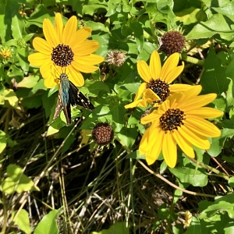  Beach Sunflowers Helianthus debilis Native annual. Full sun, sandy, well-drained soil. pH 5.2-7.2. Prostrate plant, 0.5-1’ tall, spreads to 4’ by stolons. No stratification needed. Blooms all year. Plant outside in fall, or in spring after last frost. Lightly cover seeds, keep moist. Medium salinity tolerance. Seed vigor is low; plant more than you need. Visited by native bees, skippers, and beneficial insects. Harvested 20____ | Beach Sunflowers Helianthus debilis Native annual. Full sun, sandy, well-drained soil. pH 5.2-7.2. Prostrate plant, 0.5-1’ tall, spreads to 4’ by stolons. No stratification needed. Blooms all year. Plant outside in fall, or in spring after last frost. Lightly cover seeds, keep moist. Medium salinity tolerance. Seed vigor is low; plant more than you need. Visited by native bees, skippers, and beneficial insects. Harvested 20____

