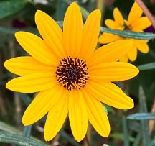
Swamp Sunflower (Narrowleaf Sunflower) Helianthus angustifolius Native perennial Keystone species. Sun to dappled sun., moist to wet soil. To 6’ tall, space 2.5-3’. Blooms 2-3” flowers Sep-Nov. Cut in half in June to force side growth. Plant outside in spring at 70º; no stratification is needed, but 1 to 3 months of cold, moist will help. Cover to depth. Keep moist after sowing. Germinates in 2 weeks. Grows quickly, short rhizomes, forms clumps, salt tolerant. Host to Silvery Checkerspot. Visited by native bees, birds, and butterflies. Seeds viable 5 yrs. if refrigerated. Harvested 20____

