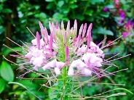
Spider Flower Cleome houtteana Annual, non-native. 3-6’ Best in full sun, moist, well-drained soil, but tolerates dry conditions. Blooms early summer into the fall. 2 mo. stratification & sow indoors Feb-March on the surface. Press in and cover lightly with sand; it needs light to germinate. Keep moist. Germinates in 1-2 weeks. Plant out in May, space 1 to 3’, Pinck back to reduce height and increase branching. Self-seeds., attract hummingbirds, hummingbird moths, bees, and butterflies. Harvested 20____

