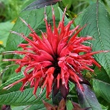
Scarlet Beebalm Monarda didyma Native herbaceous perennial. Sun to part-shade, moist to wet, rich, acid soils, 2-4’ tall, space 1-1.5’. Blooms June. Seeds mature 1-3 weeks after blooming. Tip the dried heads over, if the seeds fall out, they are mature. Flower colors will vary with seed propagation. Attracts butterflies, hummingbirds, and bees.3 mo. moist stratification. Sow seed on surface, keep moist, it needs light to germinate. Germinates in 2-3 weeks at 70º. Plant outside when 4-6” tall. Harvested 20____ Viable 7 yrs.

