|  |
| --- |
| **A close up of a tree branch with white flowers  Description automatically generatedFlowering Dogwood** *Cornus florida*  Deciduous native understory tree, Keystone Species, 25’t x 15’w. Pt. shade, moist, well-drained, blooms April**, Sow 5 to 6 inches apart in rows or in deep cells. Or seeds can be cold stratified for 3-4 mo. then put outside at 70o germinates in 2 weeks.** Host to Spring Azure butterfly, Not deer resistant. Protect saplings from buck rub. Seeds are viable for 3 years if refrigerated. Collected 20____ |

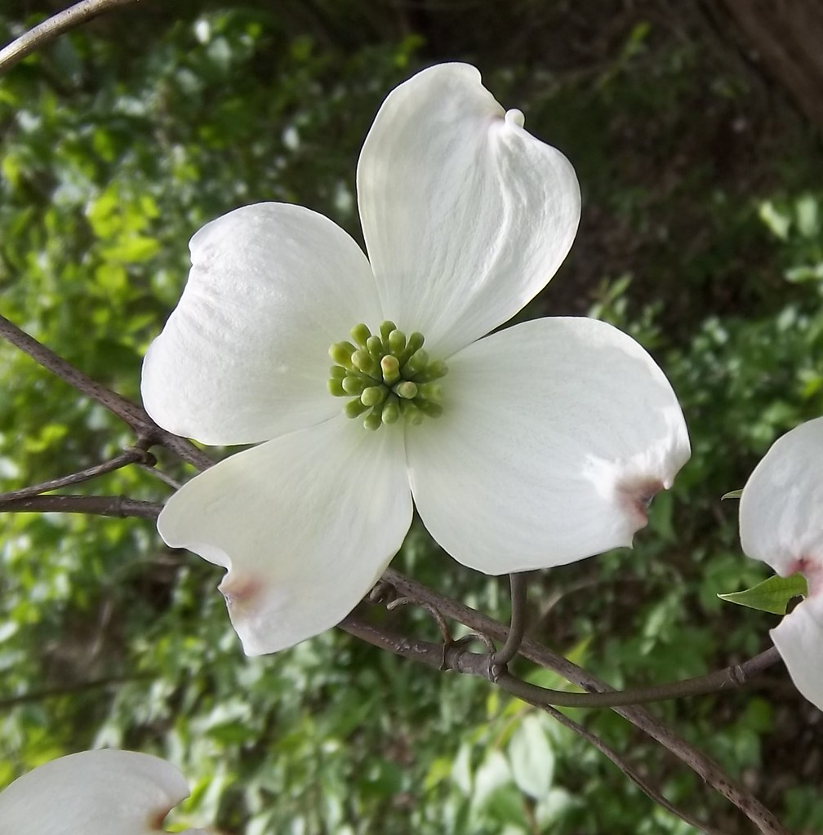

[This Photo](http://flickr.com/photos/theophilusphotography/5619682548) by Unknown Author is licensed under [CC BY-NC-ND](https://creativecommons.org/licenses/by-nc-nd/3.0/)

[This Photo](https://www.flickr.com/photos/treegrow/26469710626/) by Unknown Author is licensed under [CC BY](https://creativecommons.org/licenses/by/3.0/)