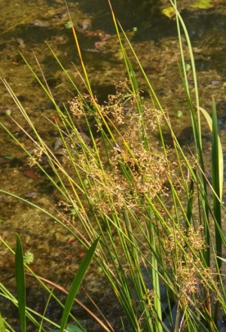  Common Rush Juncus effusus Native perennial Full sun, any moist to wet soil, wetland plant. 2-4’ tall and 2-3’wide. Semi-evergreen, rhizomatous, clump forming, blooms May-Aug. Cold, moist stratify for 2 mo. Sow at 70º on the surface, press in, needs light to germinate, and keep moist. Germinates in 1 week. Seedlings cannot withstand long periods without water. Many mammals and birds eat the seeds. Good in pots with continuous moisture. Harvested 20____ | Common Rush Juncus effusus Native perennial Full sun, any moist to wet soil, wetland plant. 2-4’ tall and 2-3’wide. Semi-evergreen, rhizomatous, clump forming, blooms May-Aug. Cold, moist stratify for 2 mo. Sow at 70º on the surface, press in, needs light to germinate, and keep moist. Germinates in 1 week. Seedlings cannot withstand long periods without water. Many mammals and birds eat the seeds. Good in pots with continuous moisture. Harvested 20____ | Common Rush Juncus effusus Native perennial Full sun, any moist to wet soil, wetland plant. 2-4’ tall and 2-3’wide. Semi-evergreen, rhizomatous, clump forming, blooms May-Aug. Cold, moist stratify for 2 mo. Sow at 70º on the surface, press in, needs light to germinate, and keep moist. Germinates in 1 week. Seedlings cannot withstand long periods without water. Many mammals and birds eat the seeds. Good in pots with continuous moisture. Harvested 20____

