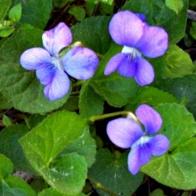
Common Blue Violet Viola sororia Native herbaceous perennial. Keystone plant, host to fritillary butterflies and moths and specialized bees. Sun to shade, prefers dappled shade. Moist to wet soils, 4-8” tall and wide. Blooms Mar-May.
2-month moist stratification or winter sow. Seeds are small, mix with sand. Sow on the surface, need light to germinate, and keep moist. Deer resistant, leaves and flowers are edible, high in vitamins A & C. Harvested 20____

