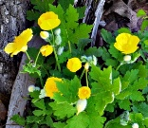
Celandine poppy Stylophorum diphyllum
Native herbaceous perennial. Pt. shade to shade, moist acid well-drained soils, 12-14” tall. Blooms March to April. Nectar for early hummingbirds. Sow seeds as soon as they ripen. Do not allow to dry out. Readily self-sows. Protect seeds from chipmunks with gauze bags. Seeds are ripe when pods open. Sow on the surface, keep moist. They germinate within two to three months. Thin seedlings when they are 4” tall. Plant spacing should be about 1’. Seeds planted in the fall will germinate in spring and bloom second season.

