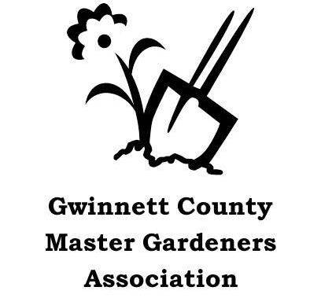Gwinnett County Master Gardener Association
2023 Grant Application Information

The Gwinnett County Master Gardener Association (GCMGA) awards project grants up to $500 for horticultural activities that beautify and/or improve the ecosystem of Gwinnett County or educate the citizens of Gwinnett County in proper horticultural practices.

Does your request qualify for GCMGA Grant consideration? Use this checklist to find out:
Project Leader is a Master Gardener and current GCMGA member who will pay 2023 dues no later than February 28, 2023.
Members may submit one application per year per location.
Project will beautify and/or improve the ecosystem of Gwinnett County or educate the citizens of Gwinnett County in proper horticultural practices.
Project location is in Gwinnett County. If not on County-owned property, written permission of property owner has been obtained (includes City-owned properties). Copy must be attached.
Project location provides free public access and is not owned by a for-profit organization.
Project has realistic goals and objectives and a written plan for continued maintenance.
A plan is in place to document project progress and completion with budget, pictures and narrative.
A grant sign (provided by GCMGA) will be displayed at the site.

Project Leader Responsibilities
- Submit project proposal with required attachments by Friday, January 20th, 2023 deadline.
- Submit Extension Office (EO) Project Form to EO if project is to qualify for Master Gardener Extension Volunteer (MGEV) hours.
- Complete and submit, to the Grant Chair all receipts and a GCMGA Expense Reimbursement Request Form for the Grant Project no later than November 15th, 2023.
- Submit to the Grant Chair, a written narrative (maximum 2 pages) of the completed project with up to four “before and after” photos by November 15th, 2023. No google links for the report are accepted. Make a project poster by January 31st which can be displayed at 2024 Plant Sale and meetings.
- If requested, provide a 5-10 minute presentation on the Grant Project at a GCMGA meeting within 12 months of the project completion.
- Funding of any expenses in excess of the grant or not approved by GCMGA grant.
- Meet all of the above responsibilities in order to be eligible for future consideration for project grants.
Plants and Materials Considered for Funding
- Perennial plants, vegetable seeds or vegetable transplants, and shrubs.
- Materials for raised beds (lumber, timbers, soil etc.) and rain barrels.
- Soil amendments, fertilizer, mulch, and planting materials to establish or refurbish a garden.
- Watering timers. Drip irrigation installation or replacement in community gardens.
- Educational materials such as books for libraries, pamphlets, teaching materials, educational signage, plant ID signage.
Items NOT Considered for Funding
- Plants listed by Georgia Exotic Pest Plant Council (www.gaeppc.org) as invasive plants in Categories 1, 1 Alert, 2 or 3.
- Hand tools, power equipment, wheelbarrows, tillers, gloves, annual flowers, annual flower seeds and pesticides.
- Sheds, arbors, walls, fences, trellises, terraces, signage (other than plant ID or educational signage).
- Benches, decorative plant containers, birdbaths and feeders, cement walkways, dry stream beds and any decorative hardscape.

