www.gwinnettmastergardeners.com  GWINNETT COUNTY MASTER GARDENER ASSOCIATION  2023 GRANT APPLICATION  Submit no later than January 20, 2023  together with all supporting documentation | 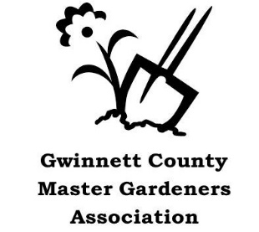

By January 20, 2023, (Friday), with all supporting documents, mail your application to:
Martha Whitman, 1485 Holly Lake Circle, Snellville, GA 30078
OR by email to the committee at: GCMGAgrants@gmail.com

Project Leader &  Contact Information | Name:  Email:
Phone / Primary: Phone / Secondary

What is the amount of grant being requested: $500 Maximum

Check List: Does your attached application contain all of the following information?

The Project Leader is a Master Gardener and current GCMGA member who will pay 2023 dues no later than February 28, 2023.

Project Title and detailed description of the work to be completed

Location of this project: street, city, and zip

This property is owned by whom?

Proposed project start date and projected completion date

Describe the benefit of this project to the Gwinnett Community it serves

Describe the education component contained in the project

Describe plans for ongoing maintenance

Approximate the number of volunteers who will work on this project

Required Attachments:
Timeline (be specific to allow the project to be properly evaluated)
Written approval of the property owner if not owned by Gwinnett County
Photos and/or drawings of the proposed project
Detailed budget of plant and materials with cost estimates

