The following BOD minutes were approved at the April 11 Board Meeting.

Gwinnett County Master Gardener’s Association
Board of Directors Meeting
January 10, 2022

Meeting was called to order at 10:04 a.m by Lynda Pollock. Zoom Meeting.

ATTENDEES
Present: President Lynda Pollock, Vice President Margaret Molyson, Past President Virginia Schofield, Secretary Karen McGinty, Committee Chairs: Amber Malloy, Alice Verner, Becky Panetta, Becky Wolary, Freda Steward, Martha Whitman, Robert Ayer, Shirley Bohm, Susan Hanson, Susan Kosenka, Tonya DeLozier
Absent: Aaron Tulin, Jack Bolton, Jane Trentin, Jessica Miller, Tabitha Potter, Sonya Lee
Guests: Tim Daly, Lisa Klein, Kim Fritz, Cindy Lubowicki, Ann Langley, Jane

EXECUTIVE COMMITTEE REPORTS

Minutes of the November 8, Board of Directors Meeting were reviewd, Freda moved to accept, Shirley seconded, followed by no discussion. The minutes were approved with no objections.

Treasurer’s Report – Jack Bolton, in absentia

We ended up the year in fairly good condition from a financial standpoint. Even with the restrictions of the pandemic, our pattern of income and spending followed that of the past several years. We were able to cover all of our operating expenses with the revenue we generated during the year. Our revenue did fall short of our expenditures, but that was mainly due to grants and scholarships. This has been our pattern for at least the past 5 years.

We started off the year with a total of $13,337 in our checking and saving account and ended up with a balance of $10,844, a difference of almost $2500. For the past few years, we have historically ended up with about $2500 to $3500 less that we started off the year.

We had a good Plant Sale in spite of COVID and also a strong Soil3 Sale. A Garden Tour is planned in 2022 which should help the revenue side significantly.

We had a successful Grant program this year with $5000 in grants being awarded and all but $128 of the awarded funds being claimed by the project managers. We also continued our tradition of awarding $2500 to Gwinnett Technical College for use as scholarships to Gwinnett students in the Horticulture Program
Our membership numbers were also good considering the limited number of in-person meetings we had. We had 168 paid members and 9 complementary members. That is 12 more paid members than in 2020 but a little less than our pre-pandemic numbers. We were also successful in signing up more of the MGEV Trainees with complementary memberships. Hopefully we can retain those Trainees as active, paying members in the future. This year we also added the ability to pay due online using PayPal. A significant number of members have renewed their membership with this option.

Account Balances:
Checking Account $2822.76
Savings Account $8,021.95

The budget for 2022 was presented to the board by Lynda. See attachment. There was no additions or corrections. Becky W. made a motion to approve the budget as provided and shown at the board meeting. Shirley seconded it, there was no discussion. The budget was passed unanimously.

President’s Report – Lynda Pollock

Set calendar for the year with a couple of additions including the deadline of Grant applications by January 21st.

The Molysons’ donated a computer to GCMGA for our use for presentations at Bethesda. The sound system people will look at it to determine our needs. Should be in place by our February meeting.

The January 17th meeting, will be in person at Bethesda, masks are required indoors per Gwinnett County. Socialize at 11:30, speaker at 12. Hospitality will provide drinks. No food or brown bag lunch.

Vice President’s Report – Margaret Molyson

March speaker is not set. David Waters from Randy’s will be speaking on Water Gardens, if he is not available then a representative from Atlanta Water Gardens is willing to speak.

Jan 17 - Bet Sobon
Feb 21 – Dr. Tim Smalley.
March: Either David Waters or Atlanta Water Gardens
April: Harvest Gwinnett
May: Photo Contest – Sonya Lee/Tonya Delozier
June: Eli Dickerson?

Discussion: In search of engraved stones, will continue to research.

Past President’s Report – Virginia Schofield

Expecting to do a fundraiser with Soil3, waiting to hear back from our contact there.

EXTENSION REPORTS

Tim Daly – Several staff members are going to a winter conference at Rock Eagle.

Debating whether to include Master Gardener volunteers at the Atlanta Home Show, January 28-30th, will know by next week.

The Master Garden Class of 2022 will be in the fall, decision will be made to include Cobb or just have Gwinnett and Dekalb.

County Extension plant sale is underway, will be looking for volunteers to unload on March 15th and for pick-up on March 17th.

The J.M. Tull YMCA looking to do a community garden, meeting forthcoming.

Advanced Training, looking to do several this year, possibility, Adopt-A-Stream.

Lisa Klein – The plant sale is coming up and information will be e-mailed about volunteers for this and other events.

Kim Fritz – We are going to have the Teacher’s MG class this summer, using the on-line class. We would like to use our MG projects as labs. For example, SE Co-Op Garden or Archie’s Garden for the vegetable lab; ornamental lab could use Vines, Kistner, or Bethesda, to allow hands on not just weeding! We need a turf location, if anyone has any ideas, please pass on.

The Food Well Alliance has given a nice size grant to Gwinnett Public Schools. Lovin ES is doing composting in the cafeteria, they need help collecting on Monday and Tuesdays, and then on Fridays helping the composting process. Discovery HS is the other school. Every year they will put on 2 schools.

I appreciate the MG’s taking on new projects, Hilary Wilson at Chesney ES; and at Parkview HS, Abby Lockhart, Amber Malloy, and Kate Foxwell.

I have sent information about grants to the school projects.

COMMITTEE REPORTS

Education/Workshops – Jessica Miller, absent – no report

Field Trips – No Chair

Garden Tour – Susan Hanson

Garden Tour money for recognition rocks could be spent on labeling plants in the garden instead. Would like to have metal labels with permanent labels.

Discussion: Rocks are an acknowledgement to the homeowner for their time, energy, and financial support of the tour. Ask homeowners to label most prominent plants, one plant of each variety. Each yard could have a plant list.

Possibly use a painted stone instead of an engraved stone. Still need to research this further.

Assign small teams of docents for each garden. Need to put committees in place for different jobs.

There are 6 gardens.

Grants – Martha Whitman

Grants reports are all turned in and posters from about half have been completed.

Given out 10 bluebird houses from the GA Piedmont Land Trust. Will send e-mail out to school groups offering them for their use. There may be a problem with how to mount them, maybe have a proposal to gather materials from recycling center, posts from chain link fence, etc. Bird houses will need baffles, possible workshop, make one for yourself, make one for a bluebird house. Lynda will pass information onto Jessica to organize.

Showed everyone a few posters that she has received so far. Possible repeat grant recipients do not need to do a poster each year. Nice to get one from initial projects to get an idea what they are doing and where our money is going. Committee will decide how to proceed in the future.

Posters will be placed on display at the GCMGA plant sale. Pictures of the posters could be put on the Facebook page as well as Instagram. Poster delivered to the office will be displayed there. I will bring posters to each in-person meeting so people could see what the project are all about.

Project applications will be received by January 21st, we will be meeting ten days later, and will send out for approval.

Historian – Freda Steward
Completed and delivered end-of-year PowerPoint for the November Meeting.

Shot pics during the November Holiday Party; sent some pics to Shirley Bohm for Bit of Dirt.

Attended briefing in December, led by Becky Wolary, on WordPress changes.

Hospitality – Alice Verner
Will have drinks set-up for the January meeting.

Photo Contest – Tonya DeLozier
Lynda and Tonya will talk about what her role will be.

Facebook/Digital Information/Social Media – Report submitted by Ann Langley
The members of the Social Media Committee continue to contribute to our Facebook and Instagram accounts. Through the holidays we have not moved forward any new projects.
I am pleased to announce that Tabitha Potter has agreed to be the Chair for the Social Media Committee for 2022.
Tabitha has taught in Gwinnett for 15 years. She is currently at Discovery High School, teaching Advanced Placement Environmental Science, on-level environmental science, and Microbiology. She founded and leads the school’s environmental club. They have a large garden, participate in Adopt-A-Road and community clean ups, and organize and manage the school’s recycling of paper, plastic bottles, and cardboard.
Tabitha finished the Master Gardener program for teachers last summer and almost has her 50 hours for the year. She is married to James Potter and, yes, she is a huge Harry Potter fan! She has 2 kids, Liam (11) and Lily is (7). Tabitha loves hiking, camping, and being outside. One of her goals is to visit all the national parks.
As she teaches during the day, Tabitha cannot join with the Board for their daytime meetings, but she will keep the Board apprised of the Committee’s progress.
Welcome, Tabitha!
Discussion, trying to get Tabitha on as an administrator on FB, working with Lisa and Margaret’s daughter Hannah.

Plant Sale – Lynda Pollock and Susan Kosenka

The Plant Sale will be held at the Lilburn Library.

The set-up will be Friday, April 29th. Set-up 2 pm – 4 pm followed by plant intake at 4 pm.
The Plant Sale will by Saturday, April 30th.
Early shopping for volunteers will be from 8 am – 9 am.
Public shopping from 9 am – 2 pm.
Breakdown from 2 pm – 3 pm.

Early sales for the volunteers, if people pick up plants during the sale, it will be full price.

We have enough tents and will rent tables. We need a pop-up tent to hold poster display.

Red Bud part of GNPS, selling Homegrown National Park signs.

Lynda will talk to Laurie Conroy at GNPS about having a booth.

Margaret will oversee setting up plant digs, and will check with Wes about his plants.

Martha will canvas for donated soil.

Publicity – Needs new chair
Everything in place,

Trainee Breakfast – Robert Ayer
Looking forward to fall class. I will get in touch with the committee.

Webmaster – Becky Wolary

Will update the website with the new chairs.

Joined Gwinnett WordPress group, to get more training, educate myself and find a possible designer, went to November meeting. Most members are professionals.

WordPress is the software that frames our website. They would like to update our website which would change our format, but I am not ready for that step at this time.

Had a training session with Freda and Margaret about using WordPress. Freda is ready to do more, she has been posting all the pictures. Margaret has started posting articles on the website. Margaret has been trying something different where articles on FB are introduced then redirected to the website.

Weed and Feed – Needs new chair

Seed Exchange – Becky Panetta
Abby Lockhart has volunteered to help me. I will be doing the inventory of the seeds. Thank you to everyone who donated seeds in November. Many of them were natives, I will try to have them available at the meeting, as some will need stratification. I need a list of native seeds that need stratification, please forward to me. Thank you.

Newsletter/Bit of Dirt – Shirley Bohm
The winter issue of the GCMGA newsletter, Bit of Dirt, will be sent out on January 15, 2022, to 171 members only.

Thanks to those who contributed articles, information and photos on the upcoming Garden Tour, new Master Gardener class, Extension Plant Sale capturing Master Gardener hours and the Holiday party for the upcoming newsletter.

Font size in the newsletter is being increased to aid reading on a cell phone screen.

A new member, Mary Lockett, was added to the newsletter team.

Old Business – Covered during reports.
New Business –
Freda will make herself available to photograph each garden for the Garden Tour.
The Garden Tour will not charge docents for a ticket, for those docents who spent time working in the garden beforehand.
Lynda will send out Garden Tour e-mail with details and will make announcement at the meeting,
Shirley would like people to think about how we can make more money or what we can cut in our current budget to balance our budget.
Lynda would like to expand our membership and distribute our flyers, possibly at small nurseries, plant sales, etc.
Margaret suggested a 50/50 money raffle.
Becky W. suggested bringing back the auction. She also suggested raising the dues to $20 in 2023. Lynda did a straw vote, and all agreed to propose a budget change for next year.
Susan suggested we wait to see how the in-person plant sale goes.
Ann suggested having a sign-up for Friends at the Plant Sale and new signees get a free plant. Lynda suggested a GCMGA booth at the plant sale.
Martha suggested we should ask Why are people leaving? RMT? Lack of hours?
Lisa said that people have left, because they have moved, some have left because of being over committed, some have lost a family member.
Ann suggested one of our biggest appeals is the friendships that develop.
Amber Malloy would like to know if there is a way we can get young people involved and interested in the program. Lynda suggested a student membership at Gwinnett Tech. Kim said she is pushing for Junior Master Garden programs, but she needs help from MG’s. Student’s parents can come to the meetings. Lisa suggested to post a flyer on the bulletin board at Gwinnett Tech and we can talk to Aaron about it, and he can mention it to the horticultural students. Ann suggested having a presenter that is kid friendly, make a concerted marketing campaign. Lisa had talked to Beth Arechiga at Creative Enterprises about doing some classes that people would pay for, how about partnering with them to do a parent/child event doing a Fairy Garden and informing the parents about the benefits of Master Gardening. Lynda will put Jessica in touch with Lisa about this.
With no other business, Lisa moved to adjourn and Martha second.
Respectfully submitted,
Karen McGinty,
January 13, 2022

Attachment: Budget as presented to BOD
Revenue

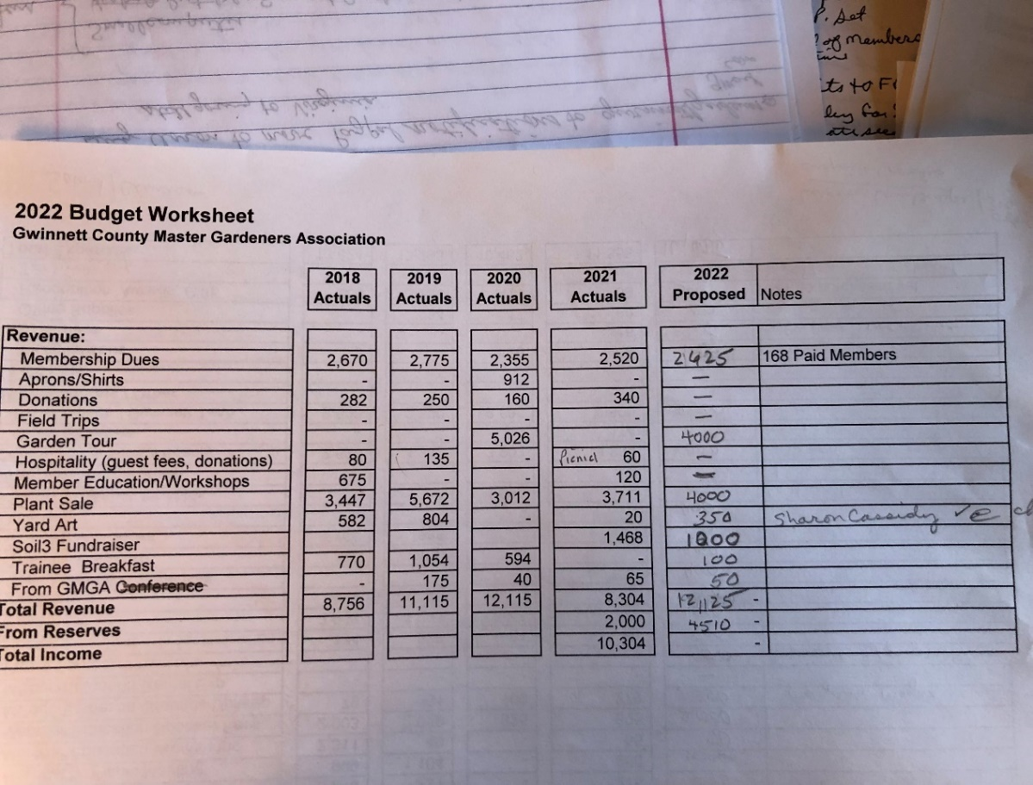

Expenses:
